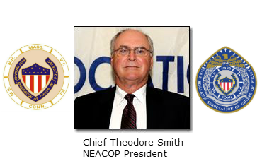
2016 New England Association of Chiefs of Police
Training Award Golf Tournament
TOURNAMENT DETAILS
Tuesday September 13, 2016
Woodstock Inn Golf Course, Woodstock Vermont 12:30 p.m. – Registration
1 p.m. – Shotgun Tournament – Scramble Format
Banquet dinner following the tournament (Paid for separately)

ENTRY FEE: $100 per Golfer (if fewer than 4 we will match you up to make foursome)
Entry Fee includes 18 holes of Golf with Cart, Tee Gift.
Player Registration/ Sponsor Information

Golfer 1 __________________________________________________________________

Golfer 2 __________________________________________________________________

Golfer 3 __________________________________________________________________

Golfer 4 __________________________________________________________________

Mail, E-mail or Fax Player Registration/ Sponsor Form to:
Chief Robbie Blish
P.O. Box 212, Woodstock, VT 05091
rblish@townofwoodstock.org; Phone: 802-457-7501; Fax: 802-457-4790
MAKE CHECKS PAYABLE TO: New England Association of Chiefs of Police

